**Project Proposal:**

Reducing Ocean Noise Pollution in BC Waters for

Orca Populations

In response to Ocean Networks Canada request for proposals: *RFP# ONC 202301: Client-Specific Dashboard Design For Marine Science Data*

By Pedro Amaral & Parker DeBruyne

For Dr. Kate Skipsey, Projects Coordinator

February 12th, 2023

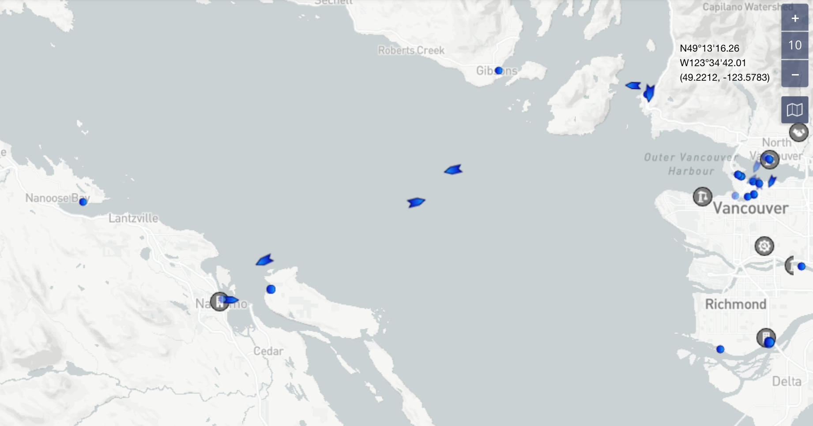

*Figure 1: Live ASI ship-tracking from marinetraffic.com* [1]

Include a table of contents based on your headings – you will, of course, come up with more descriptive headings in your report. You can auto-create this TOC using the References tab if you have used Styles to create your headings. Right click on the table to update it as you revise your report.

Table of Contents

1 - Introduction 3

2 - Proposed Solution 5

3 - Research Plan and Project Timeline 7

4 - Conclusion 9

5 - References 9

# 1 - Introduction

Ocean Networks Canada (ONC), of the University of Victoria, manages a cabled network of observation equipment along Canadian coastlines and the deep sea. Their efforts collect and supply ocean and geological data to researchers as well as the public. ONC has put forward a Request for Proposals (RFP) to help them design a web-based dashboard that allows users to access and visualize this data and improve the ocean environment for sea life [2]. Our team is confident that a dashboard can be built to influence marine noise pollution in BC waters and help killer whales.

Canadian orca populations are under threat and facing some of their lowest population rates in over 20 years, **Figure 2**. Orca pods use echolocation to find food, but when they hunt in British Columbian (BC) they are met with sounds of ferry propellors, freight ships, and coastal construction. What seems quiet above the surface is the equivalent of a rock concert to those under the sea [3]. This never-ending noise pollution creates a “blinding fog” that inhibits a whale’s ability to hunt, leading to starvation. The Strait of Georgia, off the port of Vancouver, is a high traffic area for commercial ships and marine life; it is a hot spot for both killer whales and BC Ferries, **Figure 1 & 3**. A phone call with scientists from ONC described how minor reductions in ship speed can cause significant reductions in decibel levels under water [4]. It was clear to our team that this was where we could design a dashboard to help.

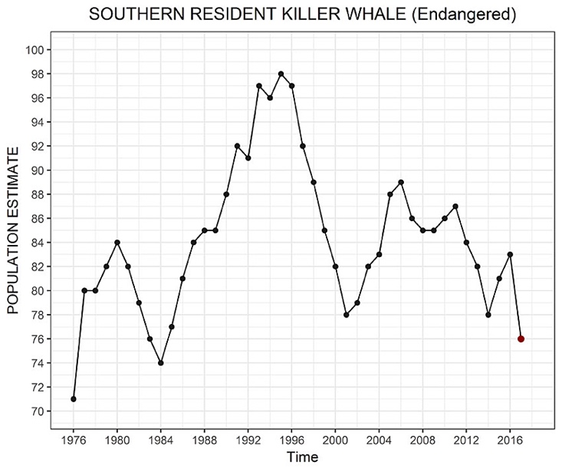*Figure 2: Orca Population vs. Time [2]*

*Figure 3: The Strait of Georgia [5]*

Any successful solution will need to address current sound levels in the Strait of Georgia and work within the limits of available technology to ship captains. To create measurability, we will explore ONC hydrophone data to gauge the current situation and set a target decibel range as our goal. We would like to research the feasibility a web-based dashboard that uses live ASI ship-tracking and ONC data to recommend “orca safe speeds” to ferry captains [7].

# 2 - Proposed Solution

Provide a preliminary description of your solution idea, and any preliminary research you have done that makes you think this would be a viable solution to the client’s problem. If this is just a short paragraph, you could include it in the Introductory section. If it is longer than a standard paragraph, include it here in its own section. Add visuals to illustrate your idea if possible (and refer to your visual in the body text). If the visual comes from a source, cite it here [2] or in the caption.

After receiving the RFP, we decided to analyze the problem in more detail, and reached a consensus on how to approach it. Since the desired goal would minimize sound pollution and its harm to Orca populations, we realized what could most efficiently solve the task: targeting the ones that caused the most harm; in this case, ship captains.

## 2.1 – Solution Overview

The solution to ONC’s problem would first involve adding new widgets to the Dashboard: an A.I.S of ships and a predictor of killer whales hotspots. Then, these widgets would mix to create a live map, of ease availability to said captains. This map would then compare each ship’s proximity to said hotspots and automatically recommend a safe speed as to produce less sound. With this approach, the Dashboard could establish a healthy balance between marine life and human action by facilitating environmentally friendly actions while maintaining productivity whenever possible and responsible.

## 2.2 – Solution Design

Upon opening the web page, WhaleWise.org, a user will first see a landing section. There will be a navbar at the top with the site’s logo on the left, and a menu button on the right that will give a dropdown selection when clicked: (a) About Us, (b) About ONC, (c) Contact Us. Below that will be a single search box centered in the middle of the screen- the background will be a darkened livestream of the Strait of Georgia from ONC’s database. Within the search bar, a user will be asked to enter their ship’s name or AIS Vessel Tracking Number, which will be assisted by a dropdown auto-complete selection. After entering their ship name, this panel will switch to a live map.

The live map will show a banner at the top displaying the recommended speed and estimated decibel levels of the vessel, based on ASI Vessel Path Tracking calculations, **Figure 4**. The user will see an icon in the center of the map representing their ship, which will be surrounded by circles representing their noise levels, and “hot spots” of orca activity in the water represented by red areas. As the ship gets closer to these hot spots, the dashboard will recommend a diminishing speed recommendation. They can of course close this map and try another search.

Public users, as opposed to ship captains, may also use the search feature to locate any ship and check on its offending decibel ranges. They will be able to scroll lower on the page to the next section which will illustrate facts about echolocation, ocean soundwave physics, orca population levels (fueled by ONC live ONC data), and the problem with coastal noise pollution.

After the educational section will be a heading that says, “Want to help out?” which is followed by a contact form for their local Member of Parliament (MP). There will be text fields where they can input their name, contact number, and email address, and zip code, as well as a pre-filled section with a generic message written to their MP.

Lastly, there will be a section of related charities and their contact information readily available. At the very bottom will be a footer section that provides a sitemap of all the pages and the contact information of a local web development company we intend to subcontract and request a quote from: INSO Web Designs.

The objective of this dashboard is four-fold:

1. To encourage captains to reduce their speed around orca zones.
2. To inform the public about the harms of noise pollution on marine life.
3. To influence policy makers to implement decibel-level restrictions on marine traffic.
4. Increase donation revenue for charities targeting this problem.

Our next steps will include refining our research, interviewing potential users, prototyping, and collecting feedback before beginning development. This approach is called Design Thinking and it is the main development strategy employed by IBM and other tech giants [8]. It allows us to maximize the accuracy of solving a problem while minimizing the time, risk, and investment involved. It all starts with conducting more research and testing our assumptions.

|  |
| --- |
|  |

Figure 4. Place holder for a visual image of your solution idea [2]

# 3 - Research Plan and Project Timeline

In order to determine whether your solution will be a feasible and beneficial solution to the client’s problem, what research will you have to do? What have you done so far? Cite any preliminary research sources you refer to here [3]. Your final goal is to write a report for the client explaining HOW and WHY they should implement your proposed solution idea. What do you need to find out in order to write that report and make an evidence-based argument that will convince the client? Make a list of specific things you will have to find out and how you plan to conduct this research. Explain why this information will be important to your final report.

*From the RFP:*

*It should place particular emphasis on researching any (not necessarily ALL) of the following aspects of the proposed solution:*

*• Technical: a recommendation on the type of technology that could be used and how it would be*

*implemented;*

*• Social: analysis of the social implications of how the proposed solution will affect users and*

*ONC staff to identify how socially acceptable the solution would be;*

*• Environmental: analysis on how the proposed solution would affect ONC’s environmental*

*impact;*

*• Regulatory: the regulatory issues that must be considered in implementing the solution; or,*

*possibly, the changes needed within University, Municipal, and Provincial levels to achieve this*

*solution;*

Include a Gantt Chart that outlines specific research steps you plan to take (and if working in a team, who will be responsible for which items). Also, your Gantt chart should include specific steps involved in planning and writing your Client Report. Refer to your Gantt chart in the body text by its caption number.

Table 1. Sample Blank Project Timeline that can be adapted for your project

|  |  |  |  |  |  |  |  |
| --- | --- | --- | --- | --- | --- | --- | --- |
| **Client Project Task** | **Person(s) Responsible** | **Wk 1** | **Wk 2** | **Wk 3** | **Wk 4** | **Wk 5** | **Wk 6** |
|  |  |  |  |  |  |  |  |
|  |  |  |  |  |  |  |  |
|  |  |  |  |  |  |  |  |
|  |  |  |  |  |  |  |  |
|  |  |  |  |  |  |  |  |
|  |  |  |  |  |  |  |  |
|  |  |  |  |  |  |  |  |
|  |  |  |  |  |  |  |  |
|  |  |  |  |  |  |  |  |

Add any additional information about your proposed research plan here. It’s best to avoid ending a section with a figure or table. You might explain how this research will allow you to make sure that the solution will achieve the objectives and abide by constraints described in your introduction.

Research framework suggestion for our project:

* What we want to study further
  + Competitor analysis
    - HALLOW Project
  + Technology used in the “wheel house”
    - Technology constraints
    - What can ONC provide?
  + Needs of captains
    - Will they slow down?
  + Decibel-level reduction goal for the Straight of Georgia
  + Local ocean DB laws
    - Legislation process
    - Decision makers
  + Methods of marketing & scalability
    - Search Engine Optimization (SEO)
    - In-person posters on BC Ferries
    - Social Media Marketing
    - Email Marketing campaign
  + Agile Design & Design Thinking approach
    - Iterations and feedback
      * Cite Agile and IBM Design Thinking
      * UX Design
        + Feedback from users
      * UI Design prototyping
        + Feedback from users
      * Ongoing feedback
        + Click-through behaviour analytics
    - Why our team will win
      * Team values & mission

After some initial research [a,b] and an interview with staff from ONC [c] into the nature of the problem, we arrived at the proposed solution. However, this topic requires more research, including but not limited to: (a) feasibility of these widgets, (b) effectiveness in the real world and (c) impact on ships productivity. Here follows a graph detailing our planned approach to investigate further into these topics, including the work already performed:

Fig. x. Planned Work Schedule.

Through these various tasks, the team would not only monitor each other’s contributions to the research, but the client report would end up more extensive, detailed and complete. We plan to divide the team into two teams: research and mock-up design. With this approach, the proposal back to the client will include both significant data and a basic representation of what actual implementation could look like.

# Conclusion

Underwater noise pollution prevents orcas from using echolocation to find their food. Locally, the biggest sources of sound come from commercial marine traffic in the Strait of Georgia- a central area for migrating killer whales. A minimal reduction in ship speed can have a significant decrease in noise pollution, but captains need to know when and where to slow down and by how much. We can provide them this information by developing an online dashboard using ONC widgets and data.

Our team will use a development approach that has been refined and tested by the most successful tech companies in North America. It does not guarantee the development of a working solution. Instead, it aims to prove or disprove that there is a solution at all, while mitigating risk. By this logic, discovering that the userbase has no interest in any dashboard is considered a success, especially when compared against the dangers of building something no one will use. If selected, our team guarantees the most accurate dashboard for targeting our user’s needs- or lowest cost of failure to our client, ONC.

We look forward to your response,

* Parker & Pedro

# References

List all the references you cited in your document here in an IEEE style References list

[1] Client Name, “Title of RFP,” or “Title of Presentation,” ENGR 240 Course Materials, semester or presentation date.

[2] Complete reference information (not just a URL…)

[3] Complete reference information

[1] https://www.marinetraffic.com/en/ais/home/centerx:-123.6/centery:49.2/zoom:10

[2] ONC REQUEST FOR PROPOSALS

[3] https://www.biologicaldiversity.org/news/press_releases/2017/orca-09-25-2017.php

[4] Reference to video call

[5] <https://coltonhash.com/acoustic-turbulence/>

[6] https://www.google.com/maps/place/Strait+of+Georgia/@49.2677205,-123.6715277,9.34z/data=!4m5!3m4!1s0x54887ff7d0eaefa7:0xe10e9cc02326b995!8m2!3d49.3568568!4d-123.8727568

[7] ASI ship tracking

[8] Design Thinking